Bedford County Fair
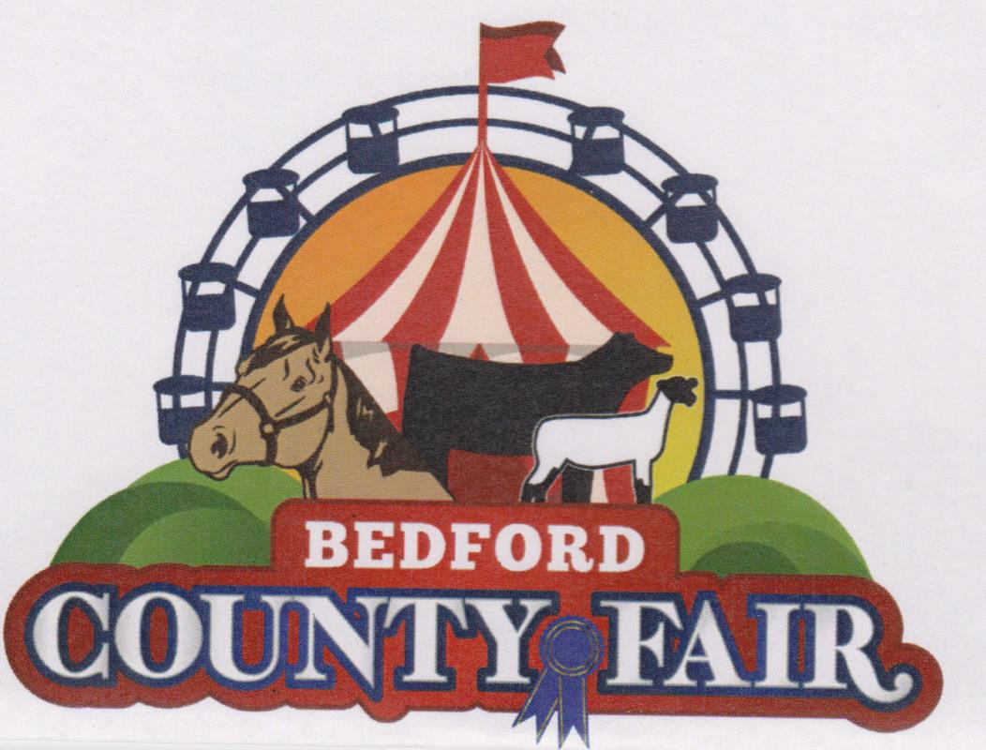
Youth Poultry Show
Friday, October 15, 2021
Entries due Monday, October 11, 2021
Judging will begin no soon than 30 minutes after fair opens.
- All poultry must be checked in Friday, October 15 beginning at 12 noon and must be checked in by 2:30. Poultry will be released Friday, October 15 at the close of the fair. No birds are to removed before close of fair unless participate has permission from Livestock Superintendent.
- Poultry exhibitors must attend a minimum or two (2) 4-H meetings.
- Exhibitors will be judged in accordance with American Poultry Association Standard of Perfection
- Exhibitors will follow the General Junior Livestock rules and regulations
- All poultry must be entered in the name or the owner and acquired before September 1, with the exception of meat birds, which should be acquired before October 1.
- All poultry must be in place by 2:30pm on Friday, October 15th. No trailers or vehicles will be allowed to move on fairgrounds once the fair opens due to safety concerns. All trailers should use the marked livestock entrance to access fairgrounds. Follow signs to parking area. Do not pull cars or trucks and trailers to tent. There will be designated times to remove livestock/poultry throughout the day and at the conclusion of each show. Cars or Truck and Trailers will NOT be allowed to move on fairgrounds to load out until fair closes.
- Market broilers must be 6-8 week old on the day or show. If age is questioned the Livestock Superintendent may ask for proof of age (ex: proof of purchase)
- There will be no market animal sale at the Bedford County Fair.
- All birds will be inspected for parasites and disease before being allowed to coop in. This may include taking a blood sample. Any bird exhibiting signs of parasites or disease will be dismissed from fairgrounds.
- Cages will be provided. If the number of entries exceeds the number of cages, the livestock superintendent can limit the number of cages per entrant. Birds originating from the same flock may share a cage if cages are limited.
- Junior exhibitors are responsible for cooping in and cooping out their birds.
- Junior exhibitors are required to handle and groom their own birds.
- There will be showmanship competition immediately following poultry judging. Specify on entry form if you will participate in showmanship. Senior 14-19, Intermediate 11-13, Junior 8-10
- Costume Class will be held immediately following showmanship.
- Poultry will be shown be show by like breed, sex and age. On entry form make sure each entry’s description includes all three (ex. Barred Rock Pullet 8 weeks)
- Exhibitors will be limited to one (1) entry in each class (breed/sex/age). The same bird cannot be exhibited in more than one class. Any poultry not pre-registered will be ineligible to show.
- Classes may be divided at the judge’s discretion.
Poultry (Classes) Divisions
*Pullets
*Hens
*Cockerel
*Cocks
*Trio – one Rooster & 2 hens same breed
* Other birds – Ducks, Geese, Turkey

Poultry Costume Class
Poultry Costume Contest is an opportunity for the youth to “dress up” their bird and themselves in a “theme” and have fun in the ring. If necessary class will be divided in age groups.

Pen/Stall/Cage Decorations
Exhibitors are encouraged to decorate their cage area using the Fair theme.
“Country Harvest”
Guidelines 1. The display/decoration should fit in the stall/pen area to which you have been assigned. 2. The Fair will provide a strand of wire above your cage. The exhibitor must provide any additional material or supplies. 3. MAKE SURE that all display materials (paper, ribbon, cords, etc.) are fastened securely so that project animals cannot dismantle or peek on it. Take all precautions to ensure animal safety. 4. Displays/decorations should include the exhibitor’s name, age, etc. 5. Electric lights MAY NOT BE USED on any display. If you wish to use any lights, they MUST BE BATTERY POWERED 6. All decorations have to be removed by exhibitor before they leave fairgrounds the day of their show.

